


Emergency Nutrition Assessment (ENA) software:
A practical user’s guide

A SMART survey is designed to be analyzed by computer using the ENA software. It can be downloaded free from either www.smartindicators.org or from www.ENA.de/ena/ena.html

The steps for using ENA for nutritional assessment are as follows:

Planning the survey 2
Name of survey 2
Sampling 2
Sample size calculation for a cross sectional anthropometric survey 2
Choosing the clusters 3
Training 3
Entering the nutritional (anthropometric and oedema) data 4
Field recording 4
Data entry 4
Checking the data for errors and plausibility 5
Data preparation and cleaning 5
Missing data 5
Data outside the required range 6
Extreme WFH data 6
Checking for measurement bias 6
Analysis of data and generating the report using a standard format 8
Analysis 8
Reporting 8
Options 9

Planning the survey
N.B. Before beginning this tutorial, import the dummy dataset provided with ENA. To do so, click the ‘open survey’ button on the ‘Data Entry Anthropometry’ tab, select the ‘anthro’ file and click ‘OK’.

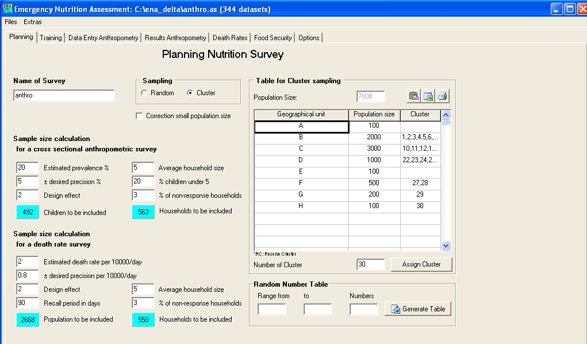

Name of survey
Start by giving the survey must be given a unique name. The dummy dataset has been named ‘anthro’.

Sampling
There are two options for sampling when conducting nutrition &/or mortality surveys. For a variety of reasons, ‘Random’ sampling is preferable to ‘Cluster’ sampling, but in most cases, random sampling is not possible due to logistic or time constraints. Therefore, cluster sampling is more often chosen as a sampling strategy. However, outcomes are often clustered in villages or households, and this clustering effect needs to be taken into consideration when calculating the precision of the estimates of prevalences and rates. The result is that a cluster sampling design requires a larger sample size for a given precision than random sampling design.

Sample size calculation for a cross sectional anthropometric survey
Estimated prevalence - If you are uncertain, enter the highest (maximum) prevalence you expect from a range of likely values. However, if you are interested in a particular prevalence (for example, the level that would trigger an emergency response), and you suspect the actual prevalence is below this threshold, enter the threshold number.

Precision - Enter the widest confidence interval you can tolerate in the estimate (normally 5% or more at high rates of prevalence, falling to about 2.5% for lower rates). This figure has a substantial effect upon the number needed for the sample.

Design effect - The default design effect for sample size calculations for malnutrition is 2.0. However, a design effect of 1.5 for malnutrition in children is often sufficient. The decision should be made individually for each emergency context.

The result of these steps is to yield the total number of children required (sample size). This figure will be automatically calculated and will appear in the ‘Children to be included’ blue box.

In addition, the number of households to be included can be calculated for planning purposes, by filling the ‘Average household size’, ‘% children under 5’ and ‘% of non-response households’ boxes. These can be estimated using previous survey data or by approximations.

Choosing the clusters
Enter the number of clusters in the ‘Number of Cluster’ box. There should always be at least 30 clusters. Twenty-six clusters is the minimum for the survey to be valid. The best way to obtain the number of clusters is to decide realistically the number of households that can be visited in one day. The higher of the two values, (a) the total sample size of children (assuming an average of one eligible child per household visited), or (b) the total households needed for the mortality survey, is divided by the number of households that can be visited in one day. This is the number of clusters that should be chosen if it is equal to or more than 30. Otherwise, 30 clusters should be used.
If there is a choice, it is better to increase the number of clusters and reduce the numbers of children in each cluster.

Enter the names of all the villages, towns, subdistricts, or other areas that will potentially be chosen to include in a cluster in the ‘Geographical unit’ column. All potential areas have to be entered. It does not matter what order the areas are entered. If they are omitted at this step, they are not part of the surveyed population. In the example shown, there are 8 units, forming the list A-H.

Enter the estimated population size for each “Geographical unit” The computer will then select the areas where there will be clusters. This is calculated randomly, with the chance of any village being chosen being proportional to its population.
This should be done only once. It will potentially introduce a bias if they are reselected. Under no circumstances should the program be rerun several times until particular villages are included or excluded.

Training
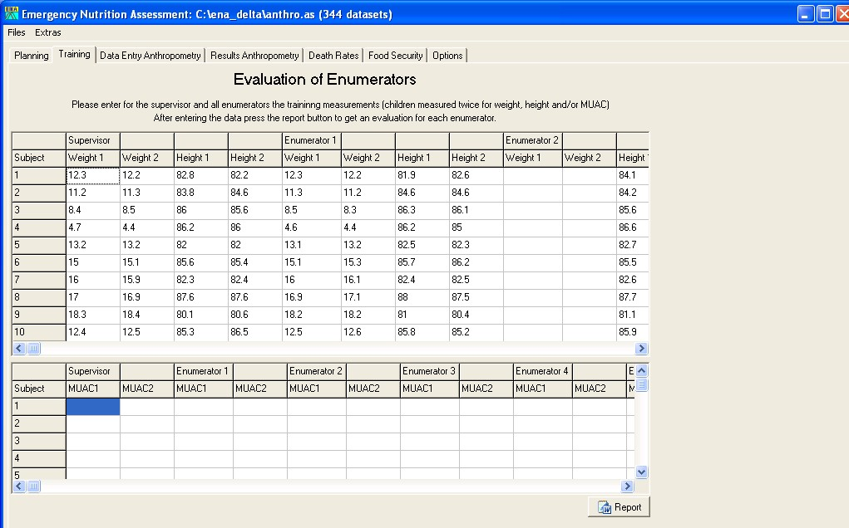

ENA contains a module to assist in evaluating the enumerators following their training. As part of the training, there should be a pilot test phase, during which the enumerators independently measure the weight, height and MUAC of a small group of children. The supervisor should do the same, and these results will be taken as the ‘gold standard’, against which the enumerators will be evaluated. There is enough space for up to 20 enumerators to be evaluated. Once the data has been entered, a report is automatically generated by clicking on the ‘Report’ button.

Entering the nutritional (anthropometric and oedema) data

Field recording
The anthropometric data can be entered onto the datasheets provided with the tool (see Annexes). These sheets are included in the software in Microsoft Word format for printing – to print these sheets, go to ‘Extras’ and select ‘Form for anthropometric survey’. One data sheet is used for each cluster.
In most surveys it is not necessary to enter the child’s name if the child is at home and the measurements are complete. Names are entered for eligible children who are absent from the house when it is visited. This enables the team to ask for the specific child when they return to the house at the end of the day.
A household number has to be assigned to each house even if it has no eligible children. They are recorded at the end of the sheet and given consecutive household numbers starting with 31 and recorded as having no children. The same household number is used for the mortality data form. The WHM (% WFH) is not calculated for each child on the datasheet in the field. The reason for having this column is for children who are going to be referred to a feeding center or other facility. The last columns are used for notes or other data that are to be collected for each child (e.g., MUAC).

Data entry
The data is entered into the computer using the ENA software. The entry panel is shown below.

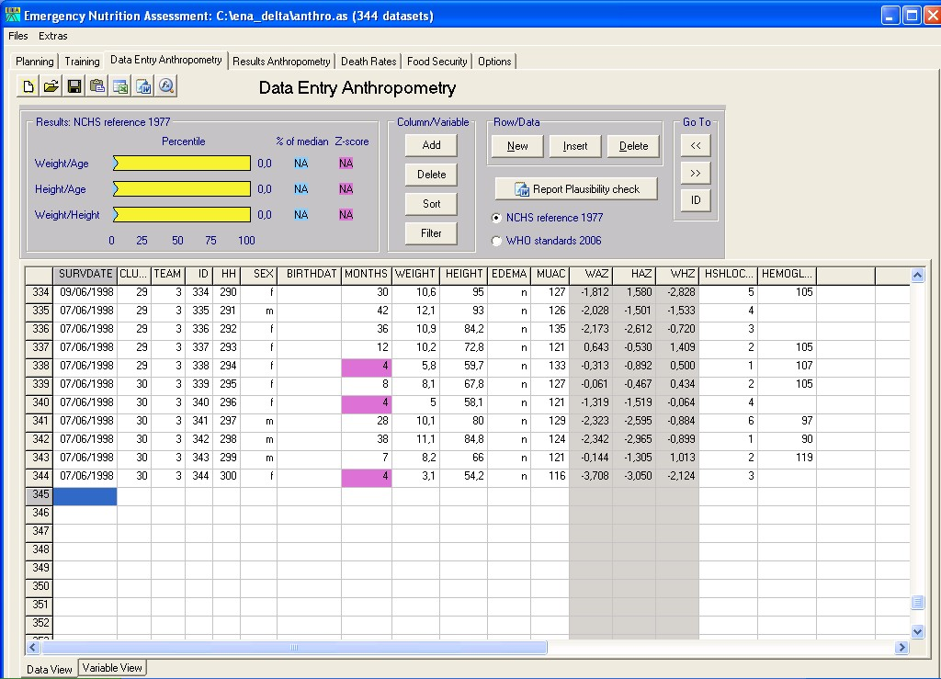

To enter data for a new individual, click on the ‘New’ button in the ‘Row/Data’ section. The survey date, cluster number and team number are entered in the first row (the village that has been chosen for the cluster is already in the database in the planning stage—the same cluster number should be used in this panel). As the data are entered these fields will default to the last entered information so that the data do not have to be entered for each subject.
The identification number will increment automatically by one for each new record that is entered.
The household number will not be incremented, as there is often more than one child in the same house. The household number needs to be entered. These must be the same household numbers as those used for entering mortality data.
Enter either the age in months or the birth date in the age fields. If the birth date is entered, the age is automatically calculated. If age is entered the birth date field is left blank. It is not necessary to enter an age to proceed. If age is not entered, it is assumed the child was selected on the basis of height and that the age is not known with sufficient accuracy to be recorded. In this case, WFA and HFA will not be calculated or entered into the database.
The anthropometric variables are automatically calculated as data are entered. If there appears to be an error in the data, the field will turn red. The cut-off points to alert the person entering the data can be set in the options screen (See Options).
If the oedema field is not entered, it defaults to oedema being absent during analysis.
N.B. It is possible to add additional variables that may be of interest, by clicking on the ‘Add’ button in the ‘Column/Variable’ section. As tempting as it is to add variables, the best principle to follow is to minimise the amount of information collected – additional questions take time, increase the burden on enumerators and data entry clerks, and the information needs to be exported and analysed separately as the automatic analysis has not been developed to take account of additional variables.

The program will list and query any value that is ± three standard deviations of the survey mean. After one or two clusters have been entered, or if there has been a previous survey, it is useful to enter in the variable view sheet the limits as the mean ± three standard deviations (or 3 z-scores) during data entry. This enables potential errors to be picked up as early as possible during data entry. These flags can be set up according to the 1977 NCHS reference or the 2006 WHO standards by selecting the appropriate check box.

Checking the data for errors and plausibility

Data preparation and cleaning
Before doing the definitive analysis, any errors in the data need to be identified and, if possible, corrected. This is done partly during data entry. An implausible or “out-of-range” value is coloured pink during data entry. The ranges should be set in the ‘Variable View’ sheet before data entry.

Data cleaning is also done using ENA’s “plausibility” check. The computer automatically examines the data to see if there are values outside the usual or expected range and lists them in a report, generated by clicking the ‘Report Plausibility check’ button. These values should be reviewed and checked against the original written data collection sheets. Any error in data entry should be corrected immediately. The report is largely self-explanatory, but the following sections can be helpful in interpreting certain elements of the plausibility report.

Missing data
If certain critical pieces of information are missing from a child’s survey record, it will not be possible to include the child in some of the anthropometric data analyses:

Age: If information on age is missing, you can still include the child in the assessment of wasting and oedema, because these do not require age. However, you will need to be sure the child is eligible to be in the survey (i.e., in the required height range of 65cm–110cm).

Sex: If information on sex is missing you should still include the child in the assessment of wasting and oedema. The reference population information on height and weight is sex specific. However, the difference between the sexes in terms of the WFH reference standards is small, and irrelevant for oedema.

Height: If information on height is missing you cannot include the child in the assessment of wasting. However, the child can still be included in an analysis of oedema, because any child with oedema is severely malnourished.

Weight: If information on weight is missing you cannot include the child in the assessment of wasting. However, the child can still be included in an analysis of oedema.

Data outside the required range
In most nutrition surveys, we are measuring children aged 6–59 months, or children who are 65cm–110cm tall. Children outside these ranges should not be included in the results. These values depend upon the defaults that have been set in the variable view sheet of the software. The default is to accept any child who is in the correct age range, even if the height is out of range. Any child outside the age range will be marked by the program. If height data are missing, the anthropometric indices of interest cannot be calculated. However, if the age is within range, the child can be included if there is oedema. The accepted height range can be altered in the variable view sheet, for example, to change the range to 60cm–100cm if the population is very stunted. These choices must be included in the report. Thus, by default, if a child is 55 months old and 112cm the child will be included. However, if the child is 65 months old, it should not be included and the computer will automatically exclude the child in the results.

Extreme WFH data
In addition to excluding children with missing information, or who are out of the required range, we also want to exclude children who have a WFH that is more likely to be the result of an error than a true measurement. There are various ways of doing this. Clearly, data that are biologically unlikely are very likely to be the result of a measurement or recording error. Thus, it is very unusual in an emergency context to find any child with a WHZ < –5.00 or a WHZ > +3.00.
Most children with wrongly measured data give values that are within the plausible range. Inclusion of such errors can be surmised from examination of the standard deviation, and other statistical checks on the data. The standard deviation should be between 0.8 and 1.2 z-score units for WFH in all well-conducted surveys (in 80% of surveys the standard deviation is between 0.9 and 1.1 z-score units). The standard deviation increases as the proportion of erroneous results in the dataset increases; this has a very dramatic effect upon the computed prevalence of wasting. For this reason, if a value is more likely to be an error than a real measurement, it should be removed from the analysis. We do this by taking the mean of the WFH data as the fixed point for describing the status of the population we are surveying. Statistically about 2.5 children out of 900 will lie outside the limits of ±3 z-score units of the mean. Less than 0.5 out of 1,000 will lie outside ±3.5 z-score units from the mean. This forms the basis for deciding if a value is more likely to be an error than a real measurement. The software will list children with these extreme values in the plausibility check list.

Checking for measurement bias
Measurement bias occurs when the team has not been adequately trained or supervised or when the measuring equipment is faulty. The best way to avoid measurement bias is to be rigorous in training and supervision and put in place careful checks to assure the quality of the equipment. Supervisors should check data collection forms at the end of each day to see if WHZ are feasible and within the plausibility range, and to see if oedema is being realistically reported.

There are several useful methods to check the quality of the anthropometric data collected during a nutrition assessment after the data has been collected:

First, the distribution of the final decimal for height and weight measurements should be examined. This will tell you if the team members are rounding weights and height to the nearest kilogram or centimetre, respectively. This phenomenon is called “digit preference.” ENA automatically examines the data for digit preference. Furthermore, it examines the digit preference for each of the teams. There may be one team that is “cutting corners” or has been improperly trained or supervised. The data can then be examined to see if there is a substantial difference if the data from that team is omitted.

Second, the standard deviation of the z-scores for WFH and HFA should be examined. As explained in the section on extreme values, this tells you if there is substantial random error in the measurements. If the standard deviation is high (over 1.2), it is likely that there are a lot of extreme values and values more than ±3 z-scores of the mean. ENA not only examines the standard deviation for the whole survey, but it also calculates the standard deviation for each team’s measurements and the number of extreme values for each team. The standard deviation and prevalence of malnutrition can then be examined omitting the data from one team. Comparison of the data with and without that particular team’s results should be undertaken to see if there is a substantial difference. Any problems should be reported.

There are other statistical measures that are computed on the data and for each team’s results. First is skewness, which measures the extent to which the results are symmetrical. The “moment of skewness” should lie between 1 and –1. Similarly, kurtosis measures whether the tails are very long (Mexican hat) or very short (pudding shaped). The “moment of kurtosis” should also lie between 1 and –1. These variables can also be computed for each team, and with one team omitted. It is extremely difficult to fabricate data for weight and height that “pass” all these checks for data distribution. In particular, the kurtosis checks whether values that might be considered to be an error by the team have been removed (sometimes referred to as “over-cleaning”). If any of the distribution checks are abnormal, the survey may be biased and the results unreliable.

There is a further check that can be made with a cluster survey. If the number of individuals with wasting in each cluster is calculated, there will be one number for each cluster. These numbers should follow a statistical distribution called a Poisson distribution. The program tests whether the numbers follow this distribution statistically. If the distribution is not Poisson, it means the population forming the sample is heterogeneous, with “pockets of malnutrition” and areas that are spared. These problems are often caused by the design of the survey, non-random selection of the villages to contain the clusters, biased selection of houses in some areas, or excessive heterogeneity in the surveyed population. The ENA software automatically calculates the Poisson distribution for wasting and compares this with the expected distribution. If the data do not follow a Poisson distribution, there will also be a larger than usual design effect. These two statistics give complementary information.

When we examine many surveys, we find that the clusters with oedema do not follow a Poisson distribution, as they should if the whole population were equally vulnerable. In fact, oedema follows what is called a “negative binomial” distribution, which means that there are some villages where lots of children get oedema and others that are relatively protected. This design effect for oedema is usually larger than for wasting, and this complicates calculation of the confidence intervals for severe malnutrition.

If there is no substantial digit preference, the standard deviation is between 0.8 and 1.2, the moments of skewness and kurtosis are within the range of 1 to –1, and the distribution of wasting follows a Poisson distribution, then one can be reasonably confident that the survey has been properly conducted, the sampling method is a fair representation of the population, and the results can be relied upon. Once the data have been cleaned and examined to ensure they are plausible, we proceed to the final analysis.

Analysis of data and generating the report using a standard format

Analysis
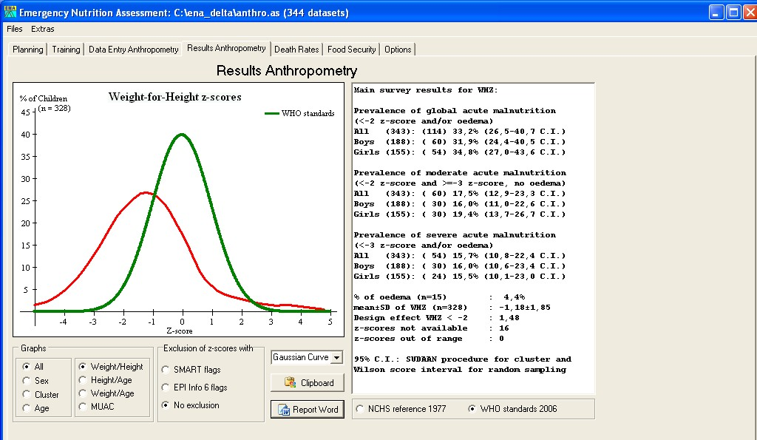

The results of the survey are immediately available upon entering the data on the ‘Results Anthropometry’ tab. There are 2 results boxes – one displays the results graphically, while the other displays the estimates of malnutrition prevalence, together with 95% confidence intervals. There are various graphical display options – weight/height, height/age, and weight/age distributions can be displayed as Gaussian curves, cumulative distributions and probability plots. The distribution of MUAC values can also be displayed as a cumulative distribution. In addition, all of these graphs can disaggregate the data by sex, cluster and age.

It is possible to exclude outlying values from the analysis, as extreme values can have a large influence on the results, and these are often caused by measurement or entry error. The options are ‘No exclusion’, exclusion of ‘SMART flags’, and exclusion of ‘EPI Info 6 flags’. The parameters for these flags can be set on the ‘Options’ tab (see ‘Options’).

The results are presented in the results box next to the graphics box. Of particular interest are the ‘Weight/Height’ and MUAC results, as these represent measures of the prevalence of acute malnutrition, whereas ‘Height/Age’ is a measure of chronic malnutrition, and ‘Weight/Age’ provides a combined measure of both chronic and acute malnutrition, and is therefore more difficult to interpret.

N.B. These results are interpretable according to the NCHS reference and the WHO standards. In general, the more recent WHO standards are to be used to assess prevalence of malnutrition, but the NCHS reference may be useful as it allows comparisons with older surveys that used this standard.

Reporting
The data are automatically analyzed and reported as a Microsoft Word file. This report can be accessed by clicking on the ‘Report Word’ button on the ‘Results Anthropometry’ tab. The survey supervisor should go through each heading and enter the relevant information. The quantitative data are presented in the tables. To put the illustrations into the report, the graphs are transferred to the clipboard within ENA (by clicking the ‘Clipboard’ button on the ‘Results Anthropometry’ tab) and pasted into the report at the appropriate place.

Options
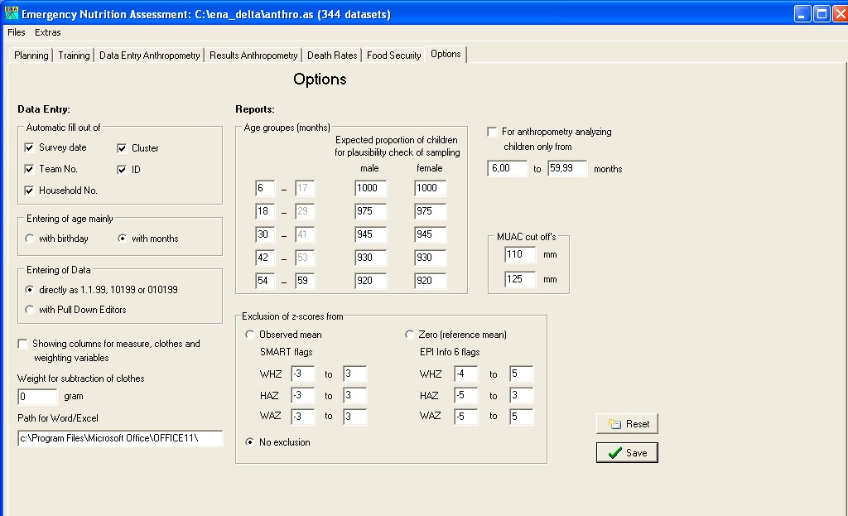

On the ‘Options’ tab, it is possible to change the various settings according to requirements.

Data Entry: It is possible to select which variables should be filled automatically, and how age should be calculated.

Reports: The age group cut-off can be altered, and the expected proportion of children in each group altered for plausibility checking of the sample.

Exclusion of z-scores: The various flag settings can be altered in this section, according to preference, or ‘No exclusion’ can be selected’.

The check box ‘For anthropometry analysing children only from’ permits the inclusion of specified age groups only in the analysis. Leave this box unchecked for inclusion of all children in the sample.

MUAC cut offs: The MUAC cut offs for ‘Severe Acute Malnutrition’ (SAM) and ‘Global Acute Malnutrition’ (GAM) can be altered. This is useful as the cut-off for SAM has recently changed from <110mm to <115mm.

